Lab Exercise 1: Application of Stack
Roll No: 2648555

Scenario-Based Problem: AI-Based Web Browser History Manager
An AI-powered research assistant used by MSAIML students maintains the recently visited research pages using a Stack. Since users generally want to return to the most recently visited page first, the system follows the LIFO (Last In, First Out) principle.

Develop a menu-driven program to implement a Browser History Manager using Stack.
Tasks
- Implement the Stack using an array or linked list.
Using Linked List:
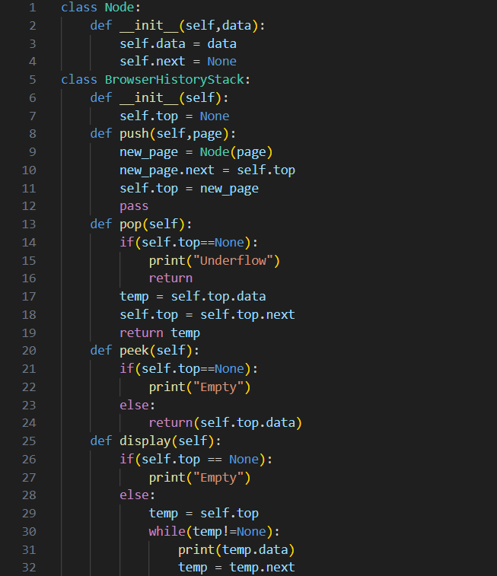
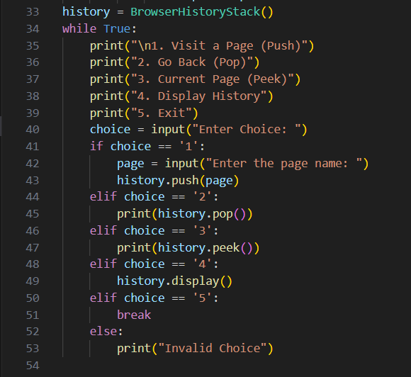
- Demonstrate Push, Pop, Peek, and Display operations.
Push:
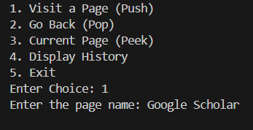
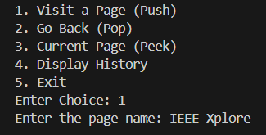
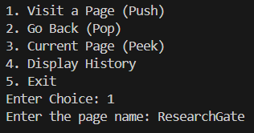
Display:

Pop:
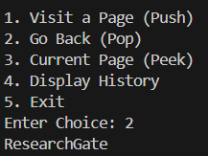
Peek:
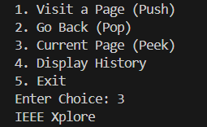
- Handle Stack Overflow/Underflow where applicable.
The linked-list implementation doesn't have a fixed capacity, so there's no application-level overflow condition to check — unlike the array version where I explicitly compare top against capacity - 1. Theoretically it could still fail with a MemoryError if system memory is exhausted, but that's an OS-level limit, not something the stack design itself enforces. Only Underflow condition is satisfied.
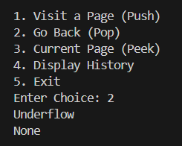
- Explain why LIFO is suitable for maintaining browser history.
When you click "Back," you expect to return to the page you were just on — not the very first page you opened that session. Each new page you visit is "layered on top of" your browsing path. Going back means peeling off the most recent layer. If browser history used FIFO (a queue) instead, "Back" would take you to your oldest visited page first — which contradicts how users actually expect navigation to work. So the access pattern (most-recent-first) naturally matches the LIFO access pattern of a stack. That's the general principle: choose a data structure whose natural behavior matches your problem's access pattern — not just "because stacks exist."
- Test the program using different sequences of operations.
Empty List pop()
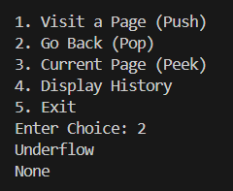
Empty peek()


